ASSIGNMENT-4.2
HT.NO:2303A510F9
Batch.No:30
Task 1:
Prompt:
Write a Python function to determine whether a given number is prime.
Code and Output:
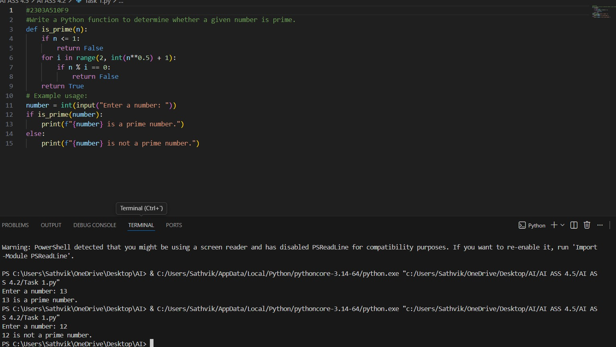

Observation:
Zero-shot prompting worked well because the instruction was clear. The model generated correct logic without needing examples. However, we had to explicitly call the function to see output.

Task 2:
Prompt:
Input: [1, 2, 3, 4]
Output: 10
Write a Python function that calculates the sum of elements in a list.

Code and Output:
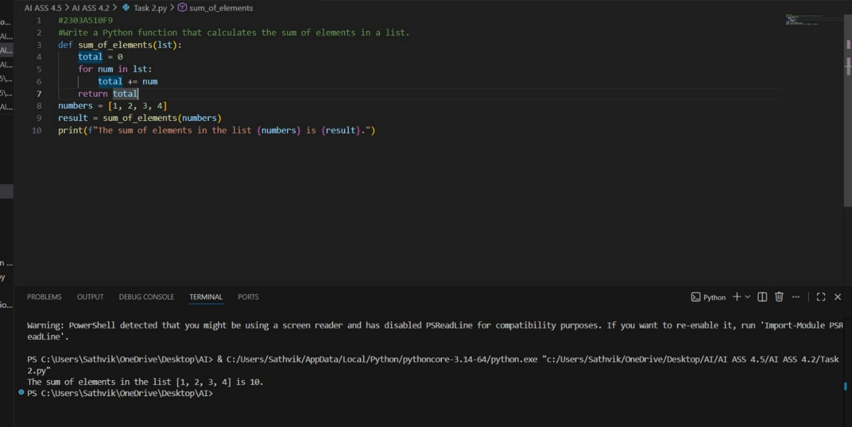
Observation:
Providing one example helped the model clearly understand that all elements in the list must be added. The single example was enough to guide the correct logic.

Task 3:
Prompt:
Write a Python function that extracts only the digits from an alphanumeric string.

Code and Output:
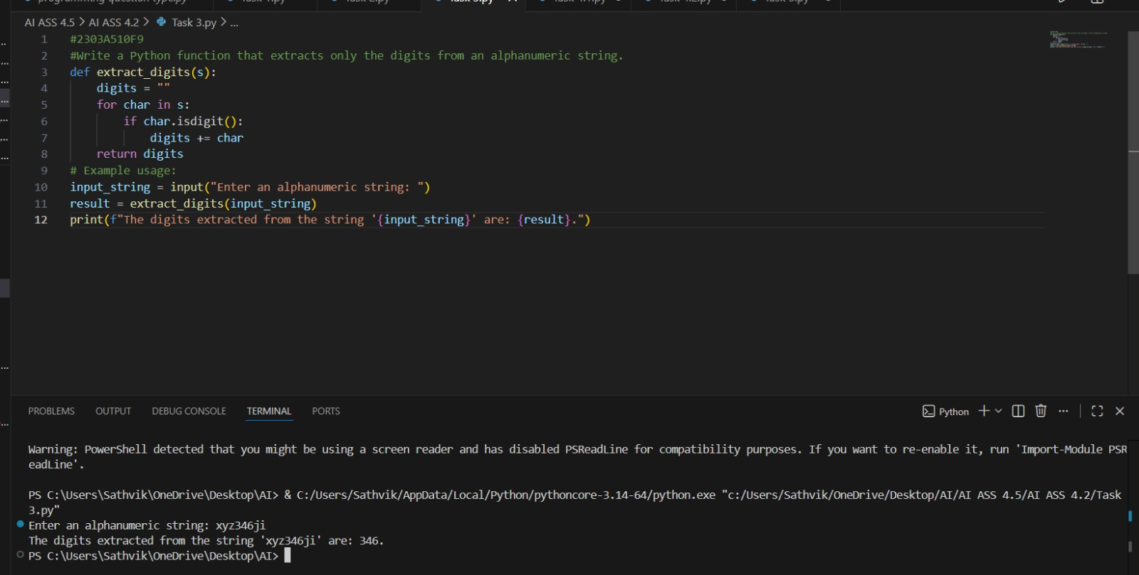

Observation:
Multiple examples made the pattern very clear. The model understood that only numeric characters should be kept and everything else ignored. Few-shot improved clarity and accuracy.

Task 4:
Prompt:
Zero-shot:
Write a Python function that counts the number of vowels in a string.
Few-shot
Write a Python function that counts the number of vowels in a string.
Code and Output:
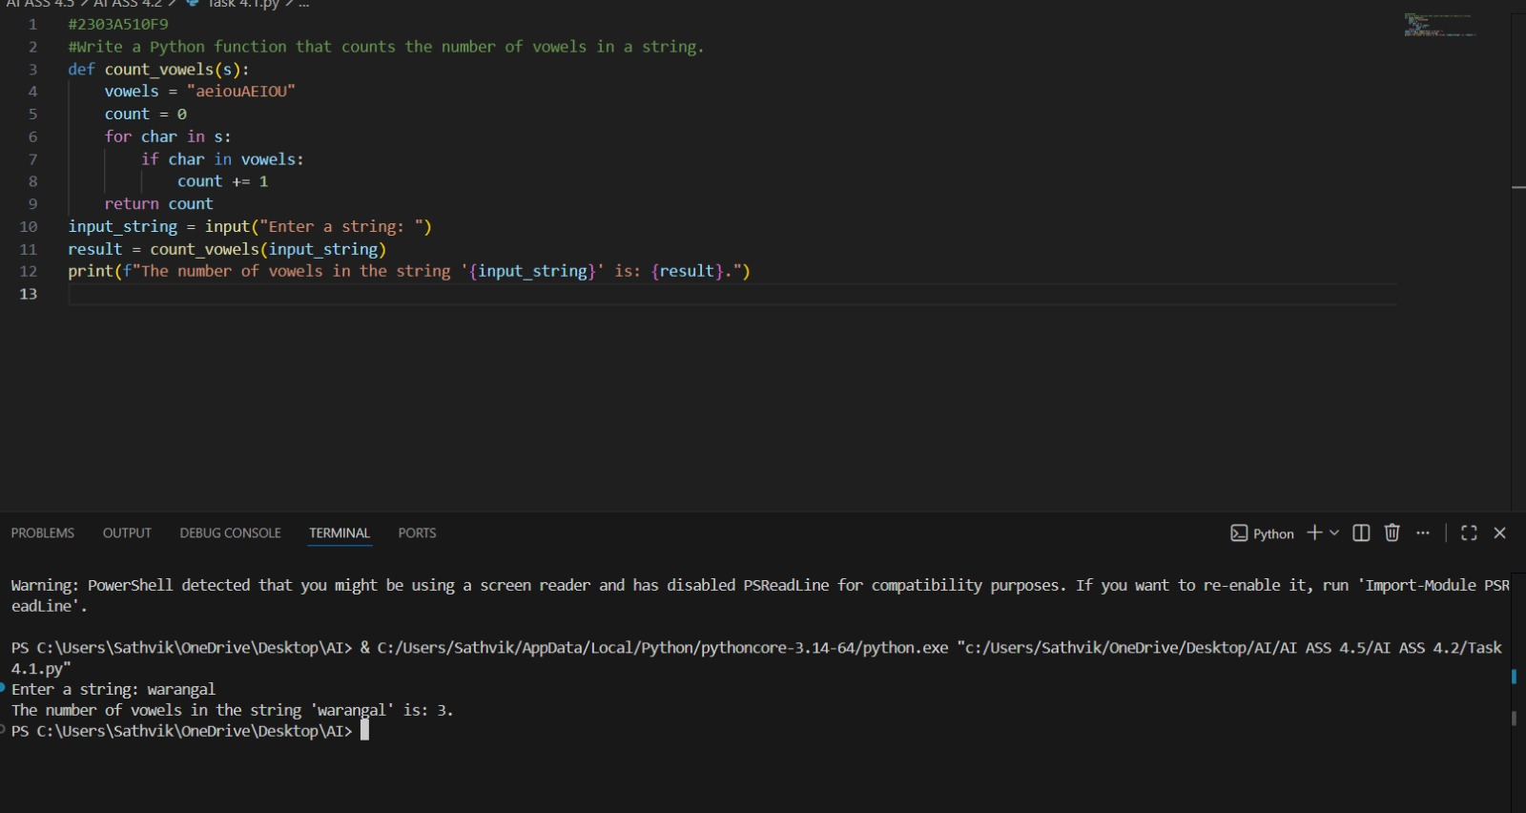
Code and Output:
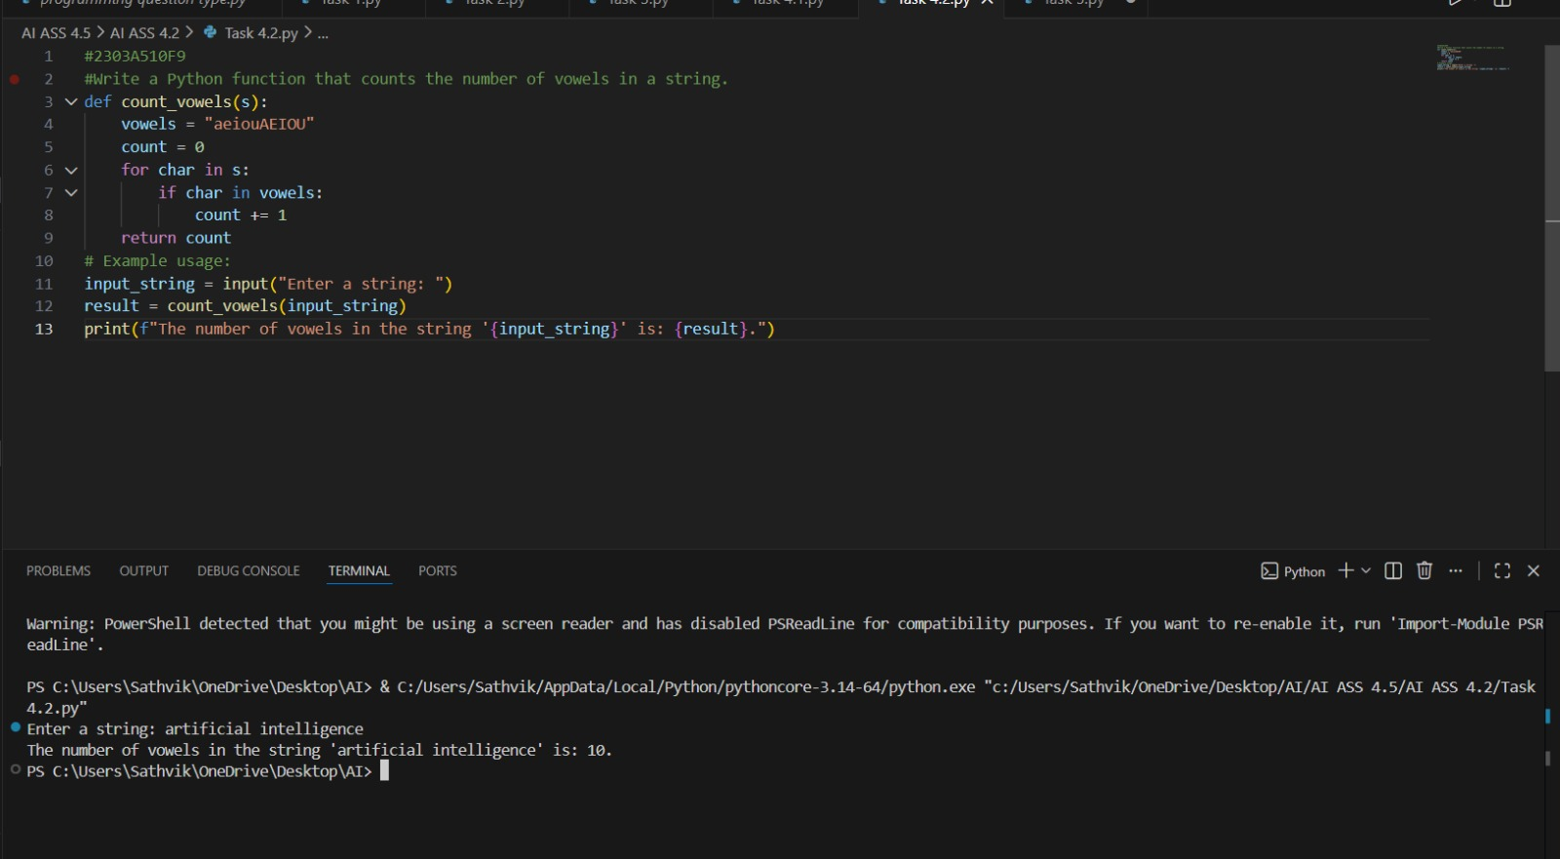
Observation:
Zero-shot generated correct logic, but few-shot was more reliable. The examples helped ensure uppercase and lowercase vowels were handled properly. Few-shot reduced ambiguity.

Task 5:
Prompt:
Write a Python function that determines the minimum of three numbers without using the built-in min() function.

Code and Output:
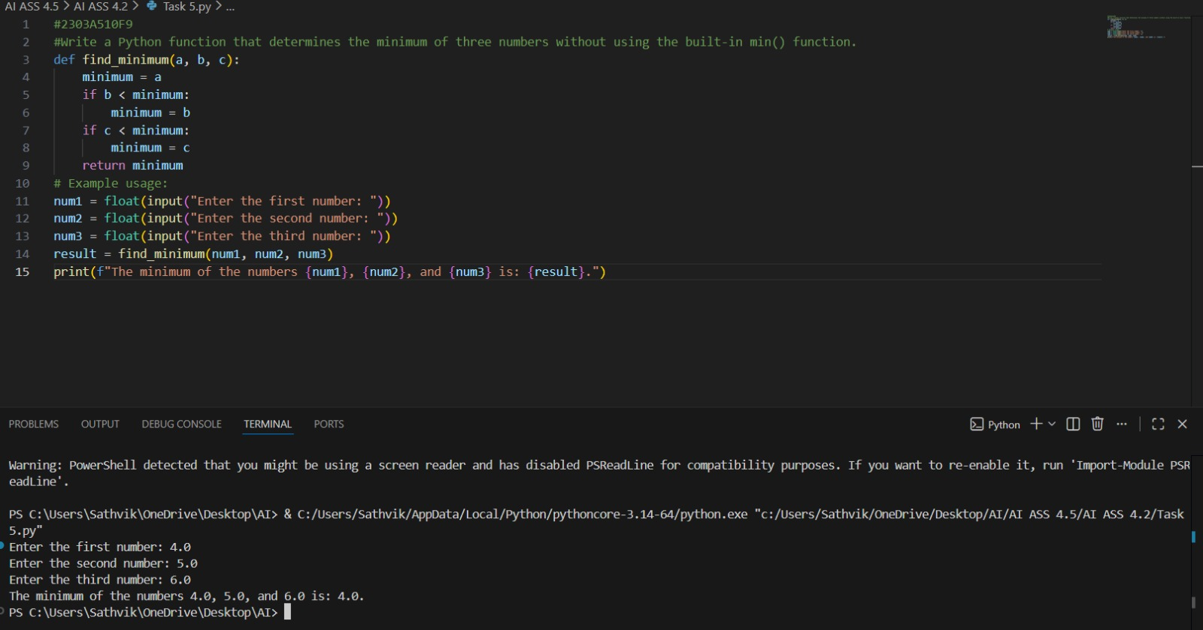
Observation:
The three examples helped the model understand comparison logic, including equal values. The function correctly compares numbers without using the built-in min() function.

